**DBMS PROJECT**

**TOPIC: ADMISSION COUNSELLING SYSTEM (JOSAA LITE)**

1. ABHISHEK PRATAP SINGH, 197103
2. MOHD. SUFIYAN ANSARI, 197151
3. RAGHAV MUKATI, 197265

**Problem Statement:-**

In this project, we have designed a database management system to store and manage the information about a student's registration and counselling process for an entrance exam. The Database will contain important information about the students and will be accessible to counselling authorities and the student himself.

This Database will contain the students' details, exam details, result of the examination, choices filled during the counselling process and its corresponding results.

This database management system will help the student and the officials during the whole examination and counselling process, which will vary from admit card release to counselling result (seat allotment).

Our Database will provide complete transparency during the whole counselling process.

This Database management system will take care of the payment history and allows only those candidates who have paid for both examination and counselling during their respective schedules.

**Tables :-**

**Candidate**

|  |  |  |
| --- | --- | --- |
| **Attribute** | **Datatype** | **Constraints and Characteristics** |
| RegistrationNumber | VARCHAR(20) | Primary key |
| FirstName | VARCHAR(20) | Not null |
| LastName | VARCHAR(20) | Not null |
| DOB | DATE | Not null |
| MobileNo | NUMBER(10) | Not null |
| Email | VARCHAR(20) | Not null |
| Gender | VARCHAR(5) | Not null |
| FatherName | VARCHAR(20) | Not null |
| Address | VARCHAR(40) | Not null |
| Password | VARCHAR(16) | Not null |
| SchoolDetails | VARCHAR(40) | Not null |

**Category**

|  |  |  |
| --- | --- | --- |
| **Attribute** | **Datatype** | **Constraints and Characteristics** |
| CategoryID | VARCHAR(20) | Primary key |
| CategoryName | VARCHAR(20) | Not null, Unique |
| TotalSeats | INT | Not null |

**Payment**

|  |  |  |
| --- | --- | --- |
| **Attribute** | **Datatype** | **Constraints and Characteristics** |
| PaymentID | VARCHAR(20) | Primary key |
| RegistrationNo | VARCHAR(20) | Foreign key , Not null |
| PaymentDate | DATE | Not null |
| Amount | FLOAT | Not null |
| PaymentFor | VARCHAR(20) | Not null |

**Admit_Card**

|  |  |  |
| --- | --- | --- |
| **Attribute** | **Datatype** | **Constraints and Characteristics** |
| RollNo | VARCHAR(20) | Primary key |
| RegistrationNumber | VARCHAR(20) | Foreign key, Not null |
| ExamDate | DATE | Not null |
| ExamTime | TIMESTAMP | Not null |
| CenterCode | VARCHAR2(20) | Not null, Foreign Key |

**Centre**

|  |  |  |
| --- | --- | --- |
| **Attribute** | **Datatype** | **Constraints and Characteristics** |
| CentreCode | VARCHAR2(20) | Primary key |
| CentreName | VARCHAR2(20) | Not null |
| City | VARCHAR2(20) | Not null |
| Address | VARCHAR2(100) | Not null |

**Result**

|  |  |  |
| --- | --- | --- |
| **Attribute** | **Datatype** | **Constraints and Characteristics** |
| RollNo | VARCHAR2(20) | Primary key, Foreign key |
| Marks | NUMBER(3,2) | **-** |
| Rank | NUMBER(8) | **-** |
| CutoffId | VARCHAR2(20) | Foreign key, Not null |

**Cutoff**

|  |  |  |
| --- | --- | --- |
| **Attribute** | **Datatype** | **Constraints and Characteristics** |
| CutoffId | VARCHAR2(20) | Primary key, Foreign key |
| CutoffMarks | NUMBER(3,2) | Not null |

**Counselling**

|  |  |  |
| --- | --- | --- |
| **Attribute** | **Datatype** | **Constraints and Characteristics** |
| ReferenceNo | VARCHAR2(20) | Primary key |
| RegistrationNo | VARCHAR2(20) | Foreign key, Not null |
| RollNo | VARCHAR2(20) | Foreign key, Not null |
| PaymentId | VARCHAR2(20) | Foreign key, Not null |

**College**

|  |  |  |
| --- | --- | --- |
| **Attribute** | **Datatype** | **Constraints and Characteristics** |
| CollegeId | VARCHAR2(20) | Primary key |
| CollegeName | VARCHAR2(20) | Not null |
| Address | VARCHAR2(100) | Not null |

**Branch**

|  |  |  |
| --- | --- | --- |
| **Attribute** | **Datatype** | **Constraints and Characteristics** |
| BranchId | VARCHAR2(20) | Primary key |
| BranchName | VARCHAR2(20) | Not null |
| No_of_seats | NUMBER | Not null |

**Choices**

|  |  |  |
| --- | --- | --- |
| **Attribute** | **Datatype** | **Constraints and Characteristics** |
| CollegeId | VARCHAR2(20) | Primary key(1), Foreign key |
| BranchId | VARCHAR2(20) | Primary key(2), Foreign key |

**ChoicesFilled**

|  |  |  |
| --- | --- | --- |
| **Attribute** | **Datatype** | **Constraints and Characteristics** |
| ReferenceNo | VARCHAR2(20) | Primary key(1), Foreign key |
| CollegeId | VARCHAR2(20) | Primary key(2), Foreign key(1) |
| BranchId | VARCHAR2(20) | Primary key(3), Foreign key(2) |

**CounsellingResult**

|  |  |  |
| --- | --- | --- |
| **Attribute** | **Datatype** | **Constraints and Characteristics** |
| ReferenceNo | VARCHAR2(20) | Primary key, Foreign key |
| CollegeId | VARCHAR2(20) | Foreign key(1), Not null |
| BranchId | VARCHAR2(20) | Foreign key(2), Not null |

**Functional Dependencies and Primary Key –**

1. **Candidate –**RegistrationNumber -> { FirstName,LastName, DOB, MobileNo, Email, Gender, FatherName, Address, Password, SchoolDetails}  
   Since all the fields depend on RegistrationNumber, (RegistrationNumber)+ -> **R**.  
   Hence, RegistrationNumber is a Primary Key
2. **Category –**CategoryID -> { CategoryName, TotalSeats}  
   CategoryName -> { CategoryID, TotalSeats}  
   Since all the fields depend on CategoryID, (CategoryID)+ -> **R**.  
   Hence, CategoryID is a Primary Key
3. **Payment –**

PaymentID -> { RegistrationNumber, PaymentDate, Amount, PaymentFor }  
RegistrationNumber -> { PaymentID, PaymentDate, Amount, PaymentFor }  
Since all the fields depend on PaymentID, (PaymentID)+ -> **R**.  
Hence, PaymentID is a Primary Key

1. **Admit_Card –**RollNo -> { RegistrationNumber, ExamDate, ExamTime }  
   RegistrationNumber -> { RollNo, ExamDate, ExamTime }  
   Since all the fields depend on RollNo, (RollNo)+ -> **R**.  
   Hence, RollNo is a Primary Key
2. **Centre –**

CentreCode -> { CentreName, City }

Since all the fields depend on CentreCode, (CentreCode)+  -> **R**.

Hence, CentreCode is Primary Key.

1. **Result –**

RollNo -> { Marks, Rank, CutoffId }

Since all fields depend on RollNo, (RollNo)+ -> **R**.

Hence, RollNo is Primary Key.

1. **Cutoff –**

CutoffId -> {CutoffMarks}

Since all fields depend on CutoffId, (CutoffId)+ -> **R**.

Hence, CutoffId is Primary Key.

1. **Counselling –**

ReferenceNo -> { RegistrationNo, RollNo, PaymentId }

RegistrationNo -> { ReferenceNo, RollNo, PaymentId }

RollNo -> { RegistrationNo, ReferenceNo, PaymentId }

PaymentId -> { RegistrationNo, RollNo, ReferenceNo }

Since all fields depend on RefrenceNo, (ReferenceNo)+ -> **R**.

Hence, ReferenceNo is Primary Key.

1. **College –**

CollegeId -> { CollegeName, Address }

Since all the fields depend on CollegeId, (CollegeId)+ -> R.  
Hence, CollegeId is Primary Key.

1. **Branch –**

BranchId -> { BranchName, No_of_seats }

Since all the fields depend on BranchId, (BranchId)+ -> R.  
Hence, BranchId is Primary Key.

1. **Choices –**

{ CollegeId, BranchId } -> { - }  
Since all attributes are part of key, ( { CollegeId, BranchId } )+ -> R.

Hence, { CollegeId, BranchId } is Primary Key.

1. **ChoicesFilled –**

{ ReferenceNo, CollegeId, BranchId } -> { - }  
Since all attributes are part of key, ( { ReferenceNo, CollegeId, BranchId } )+ -> R.

Hence, { ReferenceNo, CollegeId, BranchId } is Primary Key.

1. **CounsellingResult –**

ReferenceNo -> { CollegeId, BranchId }

Since all the fields depend on ReferenceNo, (ReferenceNo)+ -> R.  
Hence, ReferenceNo is Primary Key.

**Normalization –**

1. **Candidate**Primary key : RegistrationNumber  
   All attributes depend on the RegistrationNumber, hence the table is in 2NF.  
   All attributes depend directly on RegistratioNumber, hence the table is in 3NF.  
   All determinants ( RegistratioNumber ) is Super key, hence the table is in BCNF.
2. **Category**

Primary key: CategoryID  
All attributes depend on the CategoryID, hence the table is in 2NF.  
All attributes depend directly on CategoryID, hence the table is in 3NF.  
All determinants ( CategoryID ) is Super key, hence the table is in BCNF.

1. **Payment**

Primary key: PaymentID  
All attributes depend on the PaymentID, hence the table is in 2NF.  
All attributes depend directly on PaymentID, hence the table is in 3NF.  
All determinants ( PaymentID ) is Super key, hence the table is in BCNF.

1. **Admit_Card**Primary key: RollNo  
   All attributes depend on the RollNo, hence the table is in 2NF.  
   All attributes depend directly on RollNo, hence the table is in 3NF.  
   All determinats ( RollNo ) is Super key, hence the table is in BCNF.
2. **Centre**

Primary key: CentreCode

All attributes depend on the CentreCode, hence the table is in 2NF.

All attributes depend directly on CentreCode, hence the table is in 3NF.

All determinats ( CentreCode ) is Super key, hence the table is in BCNF.

1. **Result**

Primary key: RollNo

All attributes depend on the RollNo, hence the table is in 2NF.

All attributes depend directly on RollNo, hence the table is in 3NF.

All determinats ( RollNo ) is Super key, hence the table is in BCNF.

1. **Cutoff**

Primary key: CutoffId

All attributes depend on the CutoffId, hence the table is in 2NF.

All attributes depend directly on CutoffId, hence the table is in 3NF.

All determinats ( CutoffId ) is Super key, hence the table is in BCNF.

1. **Counselling**

Primary key: ReferenceNo

All attributes depend on the ReferenceNo, hence the table is in 2NF.

All attributes depend directly on ReferenceNo, hence the table is in 3NF.

All determinats ( ReferenceNo, RegistrationNo, RollNo, PaymentId) is Super key, hence the table is in BCNF.

1. **College**

Primary key: CollegeId

All attributes depend on the CollegeId, hence the table is in 2NF.

All attributes depend directly on CollegeId, hence the table is in 3NF.

All determinats ( CollegeId ) is Super key, hence the table is in BCNF.

1. **Branch**

Primary key: BranchId

All attributes depend on the BranchId, hence the table is in 2NF.

All attributes depend directly on BranchId, hence the table is in 3NF.

All determinats ( BranchId ) is Super key, hence the table is in BCNF.

1. **Choices**

Primary key: { CollegeId, BranchId }

All attributes are part of Primary key, hence the table is in 2NF as well as 3NF.

All determinats ( {CollegeId, BranchId} ) is Super key, hence the table is in BCNF.

1. **ChoicesFilled**

Primary key: { ReferenceNo, CollegeId, BranchId }

All attributes are part of Primary key, hence the table is in 2NF as well as 3NF.

All determinats ( {ReferenceNo, CollegeId, BranchId} ) is Super key, hence the table is in BCNF.

1. **CounsellingResult**

Primary key: ReferenceNo

All attributes depend on the ReferenceNo, hence the table is in 2NF.

All attributes depend directly on ReferenceNo, hence the table is in 3NF.

All determinats ( ReferenceNo ) is Super key, hence the table is in BCNF.

**ER DIAGRAM:**

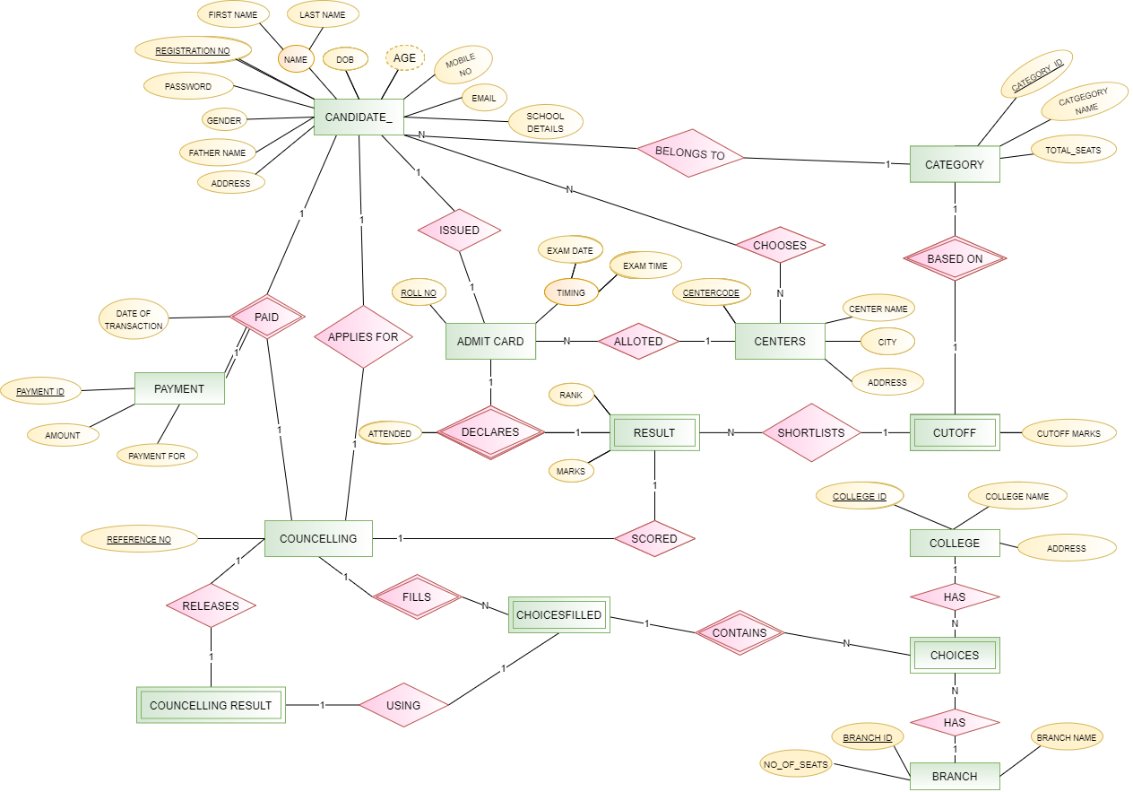

**Relational Schema with Normalised Tables:**

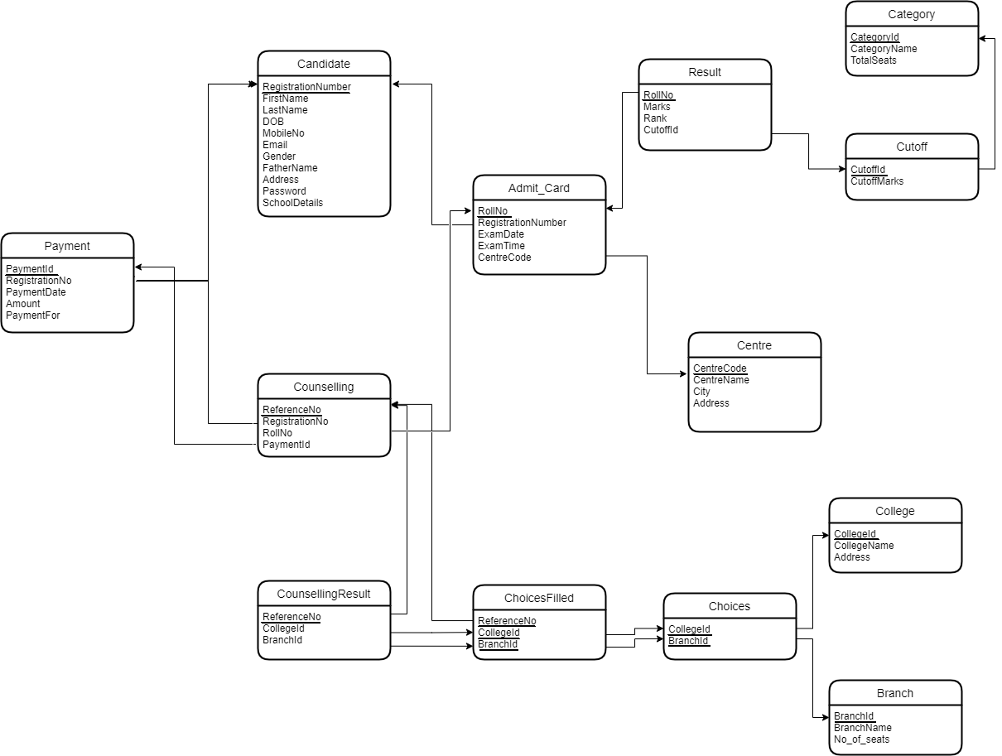

**SQL Code :**

**Creating Table**

CREATE TABLE CANDIDATE

(

    registrationNumber varchar(20) PRIMARY KEY,

    firstName varchar2(20) NOT NULL,

    lastName varchar2(20) NOT NULL,

    dob date NOT NULL,

    mobileNo number(10) NOT NULL,

    email varchar2(20) NOT NULL,

    gender varchar2(5) NOT NULL,

    fatherName varchar2(20) NOT NULL,

    address varchar2(40) NOT NULL,

    password varchar2(16) NOT NULL,

    schoolDetails varchar2(40) NOT NULL

);

CREATE TABLE CATEGORY

(

    categoryId varchar2(20) PRIMARY KEY,

    categoryName varchar2(20) NOT NULL,

    totalSeats int NOT NULL

);

CREATE TABLE PAYMENT

(

    paymentId varchar2(20) PRIMARY KEY,

    registrationNumber varchar2(20) NOT NULL,

    paymentDate date NOT NULL,

    amount float NOT NULL,

    paymentFor varchar2(20) NOT NULL,

    FOREIGN KEY (registrationNumber) REFERENCES CANDIDATE(registrationNumber)

);

CREATE TABLE CENTRE

(

    centreCode varchar2(20) PRIMARY KEY,

    centreName varchar2(20) NOT NULL,

    city varchar2(20) NOT NULL,

    address varchar2(100) NOT NULL

);

CREATE TABLE ADMIT_CARD

(

    rollNo varchar2(20) PRIMARY KEY,

    registrationNumber varchar2(20) NOT NULL,

    examDate date NOT NULL,

    examTime timestamp NOT NULL,

    centreCode varchar2(20) NOT NULL,

    FOREIGN KEY (registrationNumber) REFERENCES CANDIDATE(registrationNumber),

    FOREIGN KEY (centreCode) REFERENCES CENTRE(centreCode)

);

CREATE TABLE CUTOFF

(

    cutoffId varchar2(20) PRIMARY KEY,

    cutoffMarks number(5,2) NOT NULL,

FOREIGN KEY (cutoffId) REFERENCES CATEGORY(categoryID),

);

CREATE TABLE RESULT

(

    rollNo varchar2(20) PRIMARY KEY,

    marks number(3,2),

    rank number(8),

    cutoffId varchar2(20) NOT NULL,

    FOREIGN KEY (rollNo) REFERENCES ADMIT_CARD(rollNo),

    FOREIGN KEY (cutoffId) REFERENCES CUTOFF(cutoffId)

);

CREATE TABLE COUNSELLING

(

    referenceNo varchar2(20) PRIMARY KEY,

    registrationNumber varchar2(20) NOT NULL,

    rollNo varchar2(20) NOT NULL,

    paymentId varchar2(20) NOT NULL,

    FOREIGN KEY (registrationNumber) REFERENCES CANDIDATE(registrationNumber),

    FOREIGN KEY (rollNo) REFERENCES ADMIT_CARD(rollNo),

    FOREIGN KEY (paymentId) REFERENCES PAYMENT(paymentId)

);

CREATE TABLE COLLEGE

(

    collegeId varchar2(20) PRIMARY KEY,

    collegeName varchar2(20) NOT NULL,

    address varchar2(100) NOT NULL

);

CREATE TABLE BRANCH

(

    branchId varchar2(20) PRIMARY KEY,

    branchName varchar2(20) NOT NULL,

    no_of_seats NUMBER NOT NULL

);

CREATE TABLE CHOICES

(

    collegeId varchar2(20) NOT NULL,

    branchId varchar2(20) NOT NULL,

    FOREIGN KEY (collegeId) REFERENCES COLLEGE(collegeId),

    FOREIGN KEY (branchId) REFERENCES BRANCH(branchId),

    PRIMARY KEY(collegeId, branchId)

);

CREATE TABLE CHOICESFILLED

(

    referenceNo varchar2(20) NOT NULL,

    collegeId varchar2(20) NOT NULL,

    branchId varchar2(20) NOT NULL,

    FOREIGN KEY (referenceNo) REFERENCES COUNSELLING(referenceNo),

    FOREIGN KEY (collegeId, branchId) REFERENCES CHOICES(collegeId, branchId),

    PRIMARY KEY(referenceNo, collegeId, branchId)

);

CREATE TABLE COUNSELLINGRESULT

(

    referenceNo varchar2(20) PRIMARY KEY,

    collegeId varchar2(20) NOT NULL,

    branchId varchar2(20) NOT NULL,

    FOREIGN KEY (referenceNo, collegeId, branchId) REFERENCES CHOICESFILLED(referenceNo, collegeId, branchId)

);

TABLE INSERTION:

1. Candidate

INSERT INTO CANDIDATE VALUES(9001,'ABHISHEK','PRATAP','08-03-

2001', 7479734685,'ABHISHEK@GMAIL.COM','M','AVINASH KUMAR','BIHAR','PW1','STD1');

INSERT INTO CANDIDATE VALUES(9002,'RAGHAV ','MUKATI','11-02-2001', 7610760240,'RAGHAV @GMAIL.COM','M','MR. MUKATI','MADHYA PRADESH','PW2','STD2');

INSERT INTO CANDIDATE VALUES(9003,'SUFIYAN','ANSARI','07-04-2000', 7068502705,'SUFIYAN@GMAIL.COM','M','MOHD AHMAD','UTTAR PRADESH','PW3','STD3');

INSERT INTO CANDIDATE VALUES(9004,'ANSHUMAN','MISHRA','21-06-2002', 9875656565,'ANSHUMAN@GMAIL.COM','M','MR. MISHRA','UTTAR PRADESH','PW4','STD4');

INSERT INTO CANDIDATE VALUES(9005,'SATVIK','YANDAPALLI','09-11-2001', 9110059876,'SATVIK@GMAIL.COM','M','HANUMATH PRASAD','TELANGANA','PW5','STD5');

INSERT INTO CANDIDATE VALUES(9006,'ANUSHKA ','SINGH','22-07-2001', 9151984353,'ANUSHKA @GMAIL.COM','F','MR SINGH','BIHAR','PW6','STD6');

INSERT INTO CANDIDATE VALUES(9007,'PIYUSH','VERMA','12-12-2000', 7843798475,'PIYUSH@GMAIL.COM','M','MR VERMA','JHARKHAND','PW7','STD7');

INSERT INTO CANDIDATE VALUES(9008,'ANSHIKA','KHANNA','23-09-2000', 9793207796,'ANSHIKA@GMAIL.COM','F','SHARAD KHANNA','UTTAR PRADESH','PW8','STD8');

INSERT INTO CANDIDATE VALUES(9009,'PRATYUSH','MISHRA','12-11-2000', 7080899988,'PRATYUSH@GMAIL.COM','M','MR SRIVASTAVA','BIHAR','PW9','STD9');

INSERT INTO CANDIDATE VALUES(9010,'DIVAS','JINDAL','29-02-2000', 8985965898,'DIVAS@GMAIL.COM','M','MR JINDAL','RAJASTHAN','PW10','STD10');

1. CATEGORY

INSERT INTO CATEGORY VALUES('C01','GEN', 240);

INSERT INTO CATEGORY VALUES('C02','OBC', 120);

INSERT INTO CATEGORY VALUES('C03','GEN-PWD', 50);

INSERT INTO CATEGORY VALUES('C04','OBC-PWD', 50);

INSERT INTO CATEGORY VALUES('C05','SC', 180);

INSERT INTO CATEGORY VALUES('C06','ST', 180);

INSERT INTO CATEGORY VALUES('C07','SC-PWD', 50);

INSERT INTO CATEGORY VALUES('C08','ST-PWD', 50);

1. BRANCH

INSERT INTO BRANCH VALUES('B01','CE', 180);

INSERT INTO BRANCH VALUES('B02','CSE', 180);

INSERT INTO BRANCH VALUES('B03','META', 180);

INSERT INTO BRANCH VALUES('B04','MME', 180);

INSERT INTO BRANCH VALUES('B05','EEE', 180);

INSERT INTO BRANCH VALUES('B06','ECE', 180);

INSERT INTO BRANCH VALUES('B07','MECH', 180);

1. CENTRE

INSERT INTO CENTRE VALUES('CT01','ION ZONE','ALLAHABAD','ZONE1');

INSERT INTO CENTRE VALUES('CT02','MION ZONE','WARANGAL','ZONE1');

INSERT INTO CENTRE VALUES('CT03','BION ZONE','PATNA','ZONE3');

INSERT INTO CENTRE VALUES('CT04','PION ZONE','RAJGEER','ZONE4');

INSERT INTO CENTRE VALUES('CT05','VION ZONE','HYDERABAD','WEST ZONE');

INSERT INTO CENTRE VALUES('CT06','ION ZONE','ALLAHABAD','NORTH ZONE');

INSERT INTO CENTRE VALUES('CT07','ION ZONE','LUCKNOW','ZONE2');

INSERT INTO CENTRE VALUES('CT08','AKTU ZONE','BHOPAL','SOUTH ZONE');

1. COLLEGE

INSERT INTO COLLEGE VALUES('CL01','NITW','WARANGAL');

INSERT INTO COLLEGE VALUES('CL02','NITA','ANDHRA PRADESH');

INSERT INTO COLLEGE VALUES('CL03','MNNIT','ALLAHABAD');

INSERT INTO COLLEGE VALUES('CL04','IITB','MUMBAI');

INSERT INTO COLLEGE VALUES('CL05','IIITA','ALLAHABAD');

INSERT INTO COLLEGE VALUES('CL06','IITD','DELHI');

INSERT INTO COLLEGE VALUES('CL07','NITP','PATNA');

1. PAYMENT

INSERT INTO PAYMENT VALUES('P01','9001','30-04-2021',1500,'REG');

INSERT INTO PAYMENT VALUES('P02','9002','28-04-2021',1500,'REG');

INSERT INTO PAYMENT VALUES('P03','9003','26-04-2021',2000,'COUNSELLING');

INSERT INTO PAYMENT VALUES('P04','9004','24-04-2021',1500,'REG');

INSERT INTO PAYMENT VALUES('P05','9005','22-04-2021',1500,'REG');

INSERT INTO PAYMENT VALUES('P06','9006','20-04-2021',2000,'COUNSELLING');

INSERT INTO PAYMENT VALUES('P07','9007','18-04-2021',1500,'REG');

INSERT INTO PAYMENT VALUES('P08','9008','16-04-2021',1500,'REG');

INSERT INTO PAYMENT VALUES('P09','9009','14-04-2021',2000,'COUNSELLING');

INSERT INTO PAYMENT VALUES('P10','9010','12-04-2021',1500,'REG');

1. ADMIT_CARD

INSERT INTO ADMIT_CARD VALUES('8001','9001','15-05-2021','09:00','CT01');

INSERT INTO ADMIT_CARD VALUES('8002','9002','15-05-2021','12:00','CT02');

INSERT INTO ADMIT_CARD VALUES('8003','9003','15-05-2021','09:00','CT03');

INSERT INTO ADMIT_CARD VALUES('8004','9004','15-05-2021','09:00','CT04');

INSERT INTO ADMIT_CARD VALUES('8005','9005','15-05-2021','12:00','CT05');

INSERT INTO ADMIT_CARD VALUES('8006','9006','15-05-2021','09:00','CT06');

INSERT INTO ADMIT_CARD VALUES('8007','9007','15-05-2021','09:00','CT07');

INSERT INTO ADMIT_CARD VALUES('8008','9008','15-05-2021','12:00','CT08');

INSERT INTO ADMIT_CARD VALUES('8009','9009','15-05-2021','09:00','CT01');

INSERT INTO ADMIT_CARD VALUES('8010','9010','15-05-2021','09:00','CT02');

1. CUTOFF

INSERT INTO CUTOFF VALUES('C01',92);

INSERT INTO CUTOFF VALUES('C02',75);

INSERT INTO CUTOFF VALUES('C03',34);

INSERT INTO CUTOFF VALUES('C04',30);

INSERT INTO CUTOFF VALUES('C05',45);

INSERT INTO CUTOFF VALUES('C06',40);

INSERT INTO CUTOFF VALUES('C07',15);

INSERT INTO CUTOFF VALUES('C08',13);

1. RESULT

INSERT INTO RESULT VALUES('8001',280,'1','C01');

INSERT INTO RESULT VALUES('8002',210,'3','C02');

INSERT INTO RESULT VALUES('8003',230,'2','C03');

INSERT INTO RESULT VALUES('8004',160,'6','C04');

INSERT INTO RESULT VALUES('8005',180,'4','C01');

INSERT INTO RESULT VALUES('8006',125,'10','C02');

INSERT INTO RESULT VALUES('8007',178,'5','C03');

INSERT INTO RESULT VALUES('8008',156,'7','C04');

INSERT INTO RESULT VALUES('8009',145,'8','C05');

INSERT INTO RESULT VALUES('8010',140,'9','C06');

1. COUNSELLING

INSERT INTO COUNSELLING VALUES('RF01','9001','8001','P01');

INSERT INTO COUNSELLING VALUES('RF02','9002','8002','P02');

INSERT INTO COUNSELLING VALUES('RF03','9003','8003','P03');

INSERT INTO COUNSELLING VALUES('RF04','9004','8004','P04');

INSERT INTO COUNSELLING VALUES('RF05','9005','8005','P05');

INSERT INTO COUNSELLING VALUES('RF06','9006','8006','P06');

INSERT INTO COUNSELLING VALUES('RF07','9007','8007','P07');

INSERT INTO COUNSELLING VALUES('RF08','9008','8008','P08');

INSERT INTO COUNSELLING VALUES('RF09','9009','8009','P09');

INSERT INTO COUNSELLING VALUES('RF10','9010','8010','P10');

1. CHOICES

INSERT INTO CHOICES VALUES('CL01','B01');

INSERT INTO CHOICES VALUES('CL01','B02');

INSERT INTO CHOICES VALUES('CL01','B03');

INSERT INTO CHOICES VALUES('CL01','B04');

INSERT INTO CHOICES VALUES('CL01','B05');

INSERT INTO CHOICES VALUES('CL01','B06');

INSERT INTO CHOICES VALUES('CL01','B07');

INSERT INTO CHOICES VALUES('CL02','B01');

INSERT INTO CHOICES VALUES('CL02','B02');

INSERT INTO CHOICES VALUES('CL02','B03');

INSERT INTO CHOICES VALUES('CL02','B04');

INSERT INTO CHOICES VALUES('CL02','B05');

INSERT INTO CHOICES VALUES('CL03','B01');

INSERT INTO CHOICES VALUES('CL03','B02');

INSERT INTO CHOICES VALUES('CL03','B03');

INSERT INTO CHOICES VALUES('CL03','B06');

INSERT INTO CHOICES VALUES('CL03','B07');

INSERT INTO CHOICES VALUES('CL03','B01');

INSERT INTO CHOICES VALUES('CL04','B02');

INSERT INTO CHOICES VALUES('CL04','B03');

INSERT INTO CHOICES VALUES('CL05','B04');

INSERT INTO CHOICES VALUES('CL05','B05');

INSERT INTO CHOICES VALUES('CL06','B06');

INSERT INTO CHOICES VALUES('CL06','B07');

1. CHOICESFILLED

INSERT INTO CHOICESFILLED VALUES('RF01','CL01','B01');

INSERT INTO CHOICESFILLED VALUES('RF01','CL01','B02');

INSERT INTO CHOICESFILLED VALUES('RF01','CL02','B04');

INSERT INTO CHOICESFILLED VALUES('EF01','CL02','B05');

INSERT INTO CHOICESFILLED VALUES('RF02','CL03','B07');

INSERT INTO CHOICESFILLED VALUES('RF02','CL03','B01');

INSERT INTO CHOICESFILLED VALUES('RF03','CL04','B02');

INSERT INTO CHOICESFILLED VALUES('RF03','CL04','B03');

INSERT INTO CHOICESFILLED VALUES('RF03','CL05','B04');

INSERT INTO CHOICESFILLED VALUES('RF04','CL05','B05');

INSERT INTO CHOICESFILLED VALUES('RF04','CL01','B01');

INSERT INTO CHOICESFILLED VALUES('RF04','CL01','B02');

INSERT INTO CHOICESFILLED VALUES('RF04','CL02','B04');

INSERT INTO CHOICESFILLED VALUES('RF05','CL02','B05');

INSERT INTO CHOICESFILLED VALUES('RF05','CL03','B07');

INSERT INTO CHOICESFILLED VALUES('RF05','CL03','B01');

INSERT INTO CHOICESFILLED VALUES('RF05','CL04','B02');

INSERT INTO CHOICESFILLED VALUES('RF05','CL04','B03');

INSERT INTO CHOICESFILLED VALUES('RF06','CL05','B04');

INSERT INTO CHOICESFILLED VALUES('RF06','CL05','B05');

INSERT INTO CHOICESFILLED VALUES('RF07','CL02','B01');

INSERT INTO CHOICESFILLED VALUES('RF07','CL02','B02');

INSERT INTO CHOICESFILLED VALUES('RF07','CL02','B03');

INSERT INTO CHOICESFILLED VALUES('RF08','CL02','B04');

INSERT INTO CHOICESFILLED VALUES('RF08','CL02','B05');

INSERT INTO CHOICESFILLED VALUES('RF09','CL03','B01');

INSERT INTO CHOICESFILLED VALUES('RF09','CL03','B02');

INSERT INTO CHOICESFILLED VALUES('RF10','CL03','B03');

INSERT INTO CHOICESFILLED VALUES('RF10','CL03','B01');

INSERT INTO CHOICESFILLED VALUES('RF10','CL04','B02');

INSERT INTO CHOICESFILLED VALUES('RF10','CL04','B03');

1. COUNSELLINGRESULT

INSERT INTO COUNSELLINGRESULT VALUES('RF01','CL01','B01');

INSERT INTO COUNSELLINGRESULT VALUES('RF02','CL03','B01');

INSERT INTO COUNSELLINGRESULT VALUES('RF03','CL05','B04');

INSERT INTO COUNSELLINGRESULT VALUES('RF04','CL01','B02');

INSERT INTO COUNSELLINGRESULT VALUES('RF05','CL04','B02');

INSERT INTO COUNSELLINGRESULT VALUES('RF06','CL05','B05');

INSERT INTO COUNSELLINGRESULT VALUES('RF07','CL02','B03');

INSERT INTO COUNSELLINGRESULT VALUES('RF08','CL02','B05');

INSERT INTO COUNSELLINGRESULT VALUES('RF09','CL03','B02');

INSERT INTO COUNSELLINGRESULT VALUES('RF10','CL03','B01');

THANK YOU

1. ABHISHEK PRATAP SINGH, 197103

2. MOHD. SUFIYAN ANSARI, 197151

3. RAGHAV MUKATI, 197265